Lab 4 Configuring, Managing, and Troubleshooting Resource Access

**Task 3 – Activity**

**(Save your work because your answers may be required to provide in the Mid-Semester and Final Examination.)**

# Activity 4-1 Installing Windows Search Service

**Time Required**: Approximately 10 minutes

**Objective**: Install Windows Search Service for faster folder and file searches.

Description: Having Windows Search Service installed on a server can save time and energy for server administrators and operators in an organization. In this activity, you install the Windows Search Service feature, which complements the File and Storage Services role. The File and Storage Services role should already be installed, which is the default when you install Windows Server 2016.

**Requirements**: Take screenshots on Step 6, 7, 9, 12. Complete a question on Step 14.

1. Open Server Manager.
2. Click Manage under the title bar in Server Manager and click Add Roles and Features.
3. If you see the Before you begin window in the Add Roles and Features Wizard, click Next.
4. Ensure Role-based or feature-based installation is selected in the Select installation type window and click Next.
5. Ensure your server is selected in the Select destination server window and click Next.
6. Ensure that File and Storage Services (x of 12 installed) is already marked as installed and click Next (where the x stands for the number of role services installed).

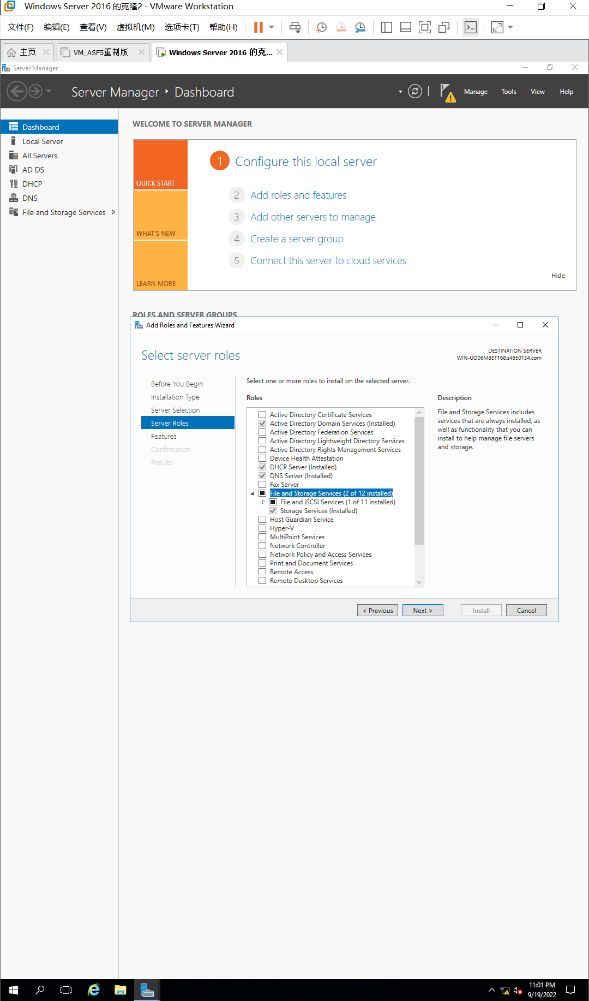

Figure 1.1 Ensure marked File and Storage Services

1. In the Select features window, scroll to and then click Windows Search Service. Click Next.

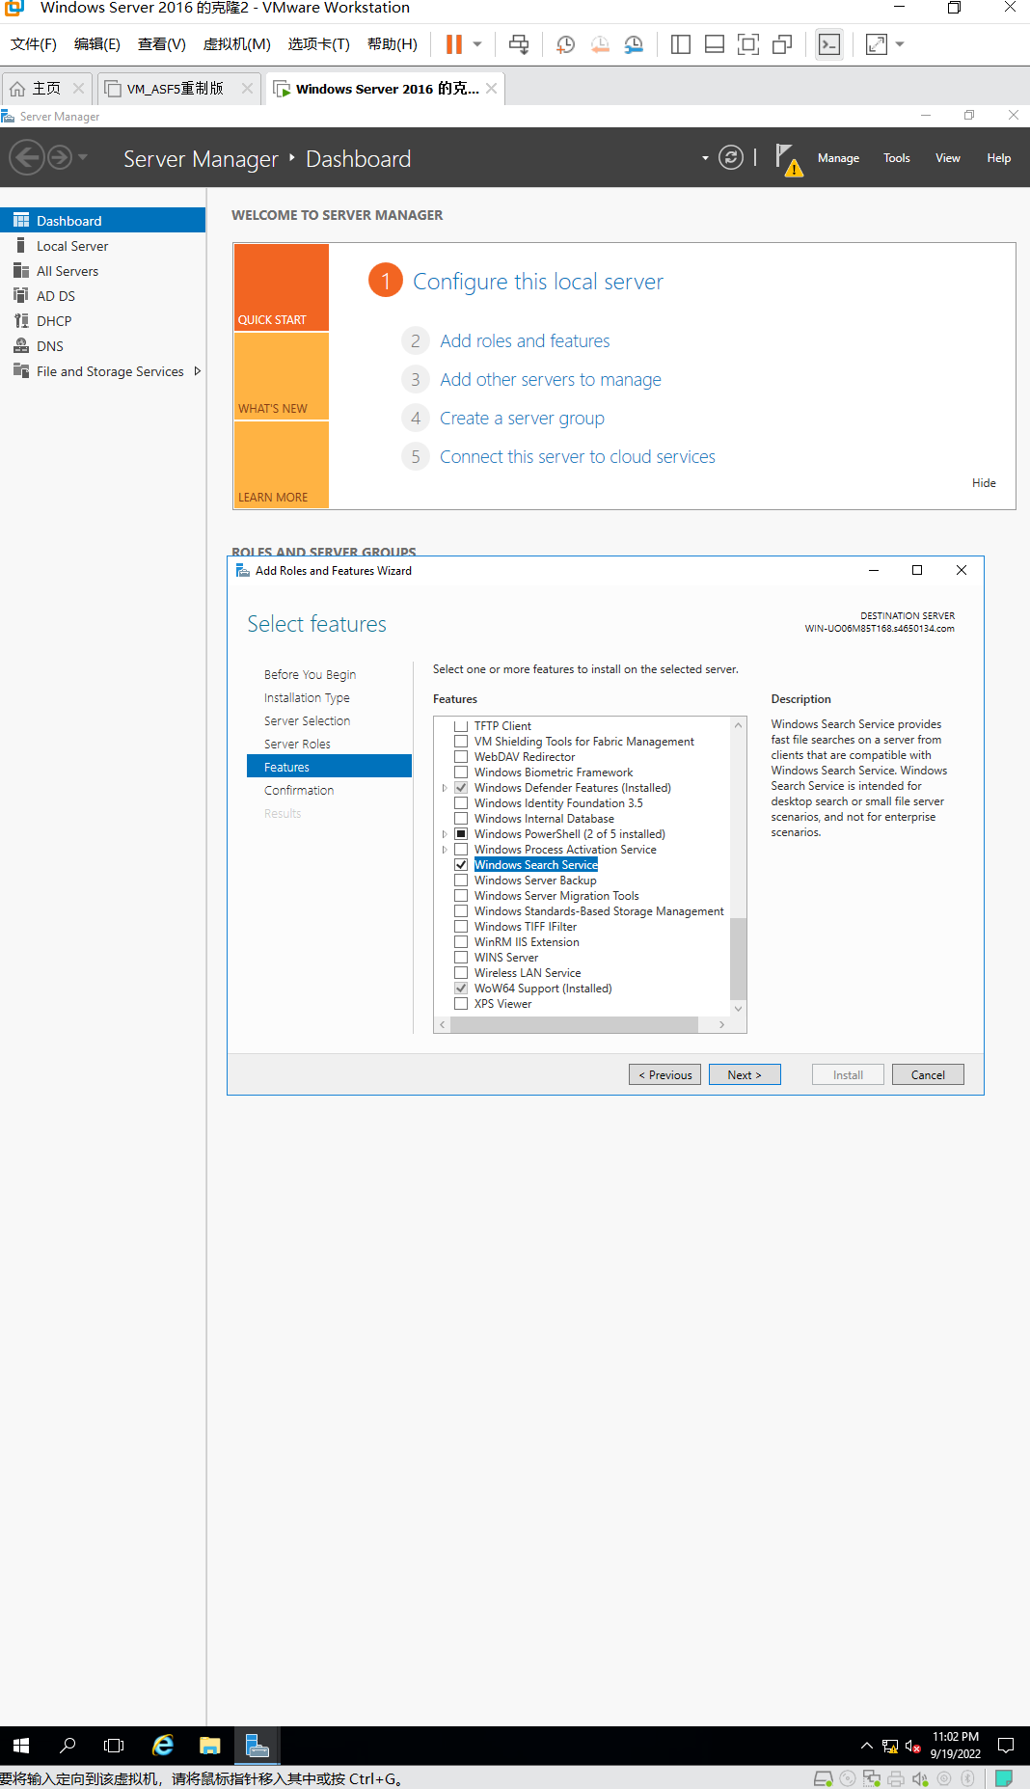

Figure 1.2 Select Windows Search Service

1. Click Install in the Confirm installation selections window.
2. Ensure that the installation succeeded and click Close in the Installation progress window. 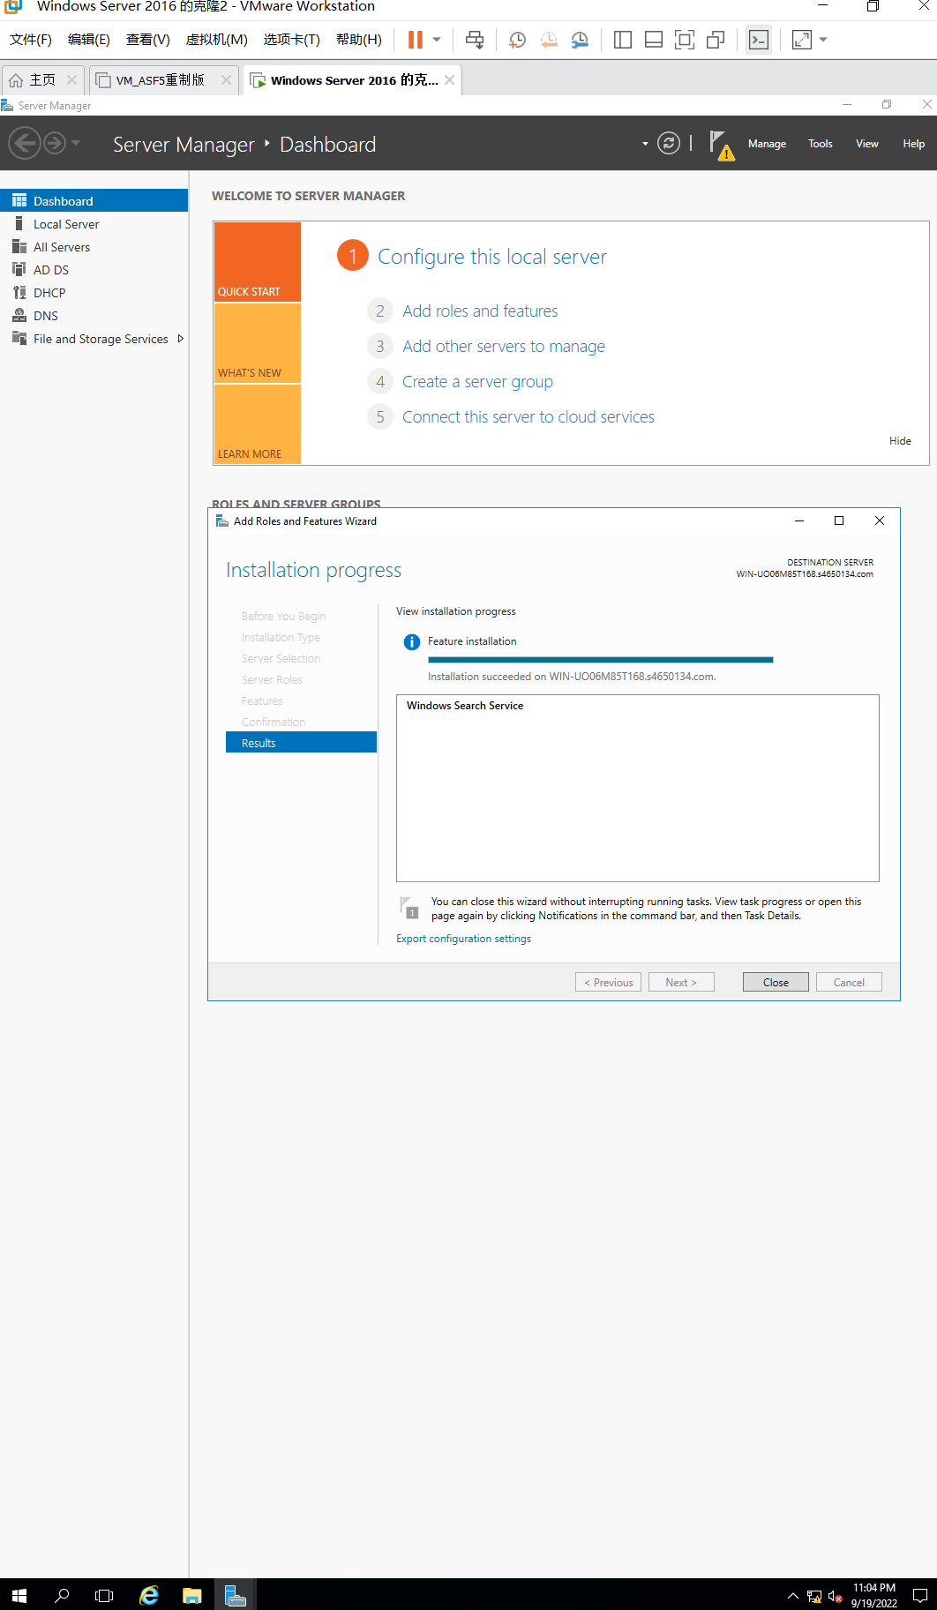

Figure 1.3 Installation succeeded

1. Make sure that the Windows Search service is started by clicking Tools in Server Manager and clicking Services.
2. In the Services Window, double-click Windows Search under the Name column.
3. In the Windows Search Properties (Local Computer) dialog box, ensure that the Startup type is set to Automatic. Click Apply.

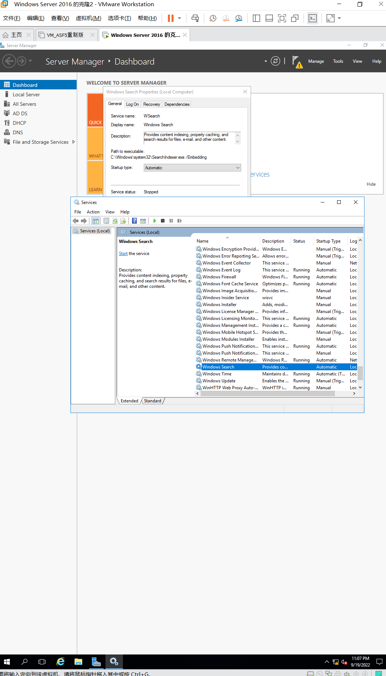

Figure 1.4 Startup type is set to Automatic

1. Click Start in the Windows Search Properties (Local Computer) dialog box.
2. Wait for the Service Control box to show the service is started. Click OK in the Windows Search Properties (Local computer) dialog box.

***.*** *Try to stop the Windows Search Service, record the panel.*

Answer: The status does not show running

1. Close the Services window.

# Activity4-2: Auditing a Folder

**Time Required**: Approximately 20 minutes

**Objective**: Configure auditing on a folder to monitor how it is accessed and who is making changes to the folder.

**Description**: Now that you have created the Documentation folder, you decide to monitor how people are using the folder as well as the frequency of use. To do this, you set up auditing on that folder. To start, you must first enable auditing through a Group Policy in Active Directory, which is a one-time setup (you learn more about configuring group policies in following lecture, Securing Windows Server 2016). Once auditing is enabled, you can audit many types of objects, including specific folders. After you enable auditing, you configure the Documentation folder you created so that activity in the Documentation folder can be audited.

**Requirements**: Take screenshots on Step 3, 8, and 17. Complete a question on Step 15.

1. Right-click Start and click Run, enter mmc in the Run box, and click OK.
2. Click File and click Add/Remove Snap-in.
3. Click the Group Policy Management Editor (the second Group Policy option under available snap-ins) and click Add.

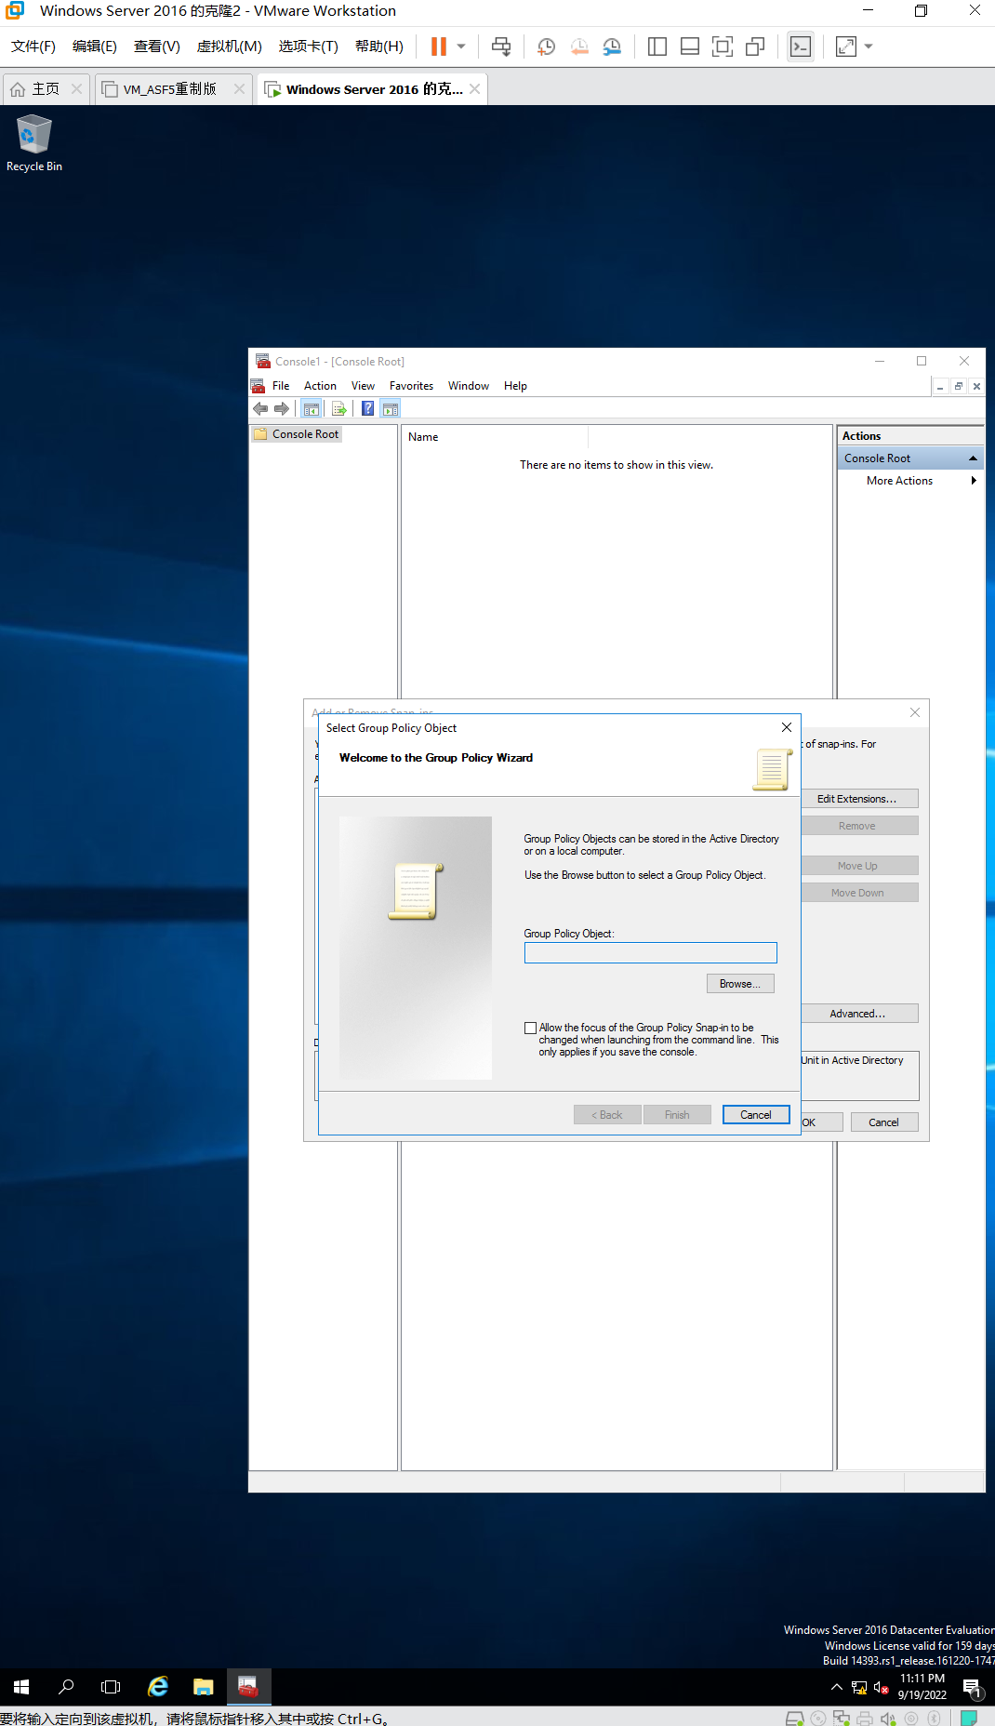

Figure 2.1 Add Group Policy Management Editor

1. In the Select Group Policy Object dialog box, click the Browse button.
2. In the Browse for a Group Policy Object dialog box, click Default Domain Policy and click OK.
3. Click Finish in the Select Group Policy Object dialog box.
4. Click OK in the Add or Remove Snap-ins dialog box.
5. In the left pane, click the right pointing arrow in front of Default Domain Policy [computer- name.domainname] to display the items under it.

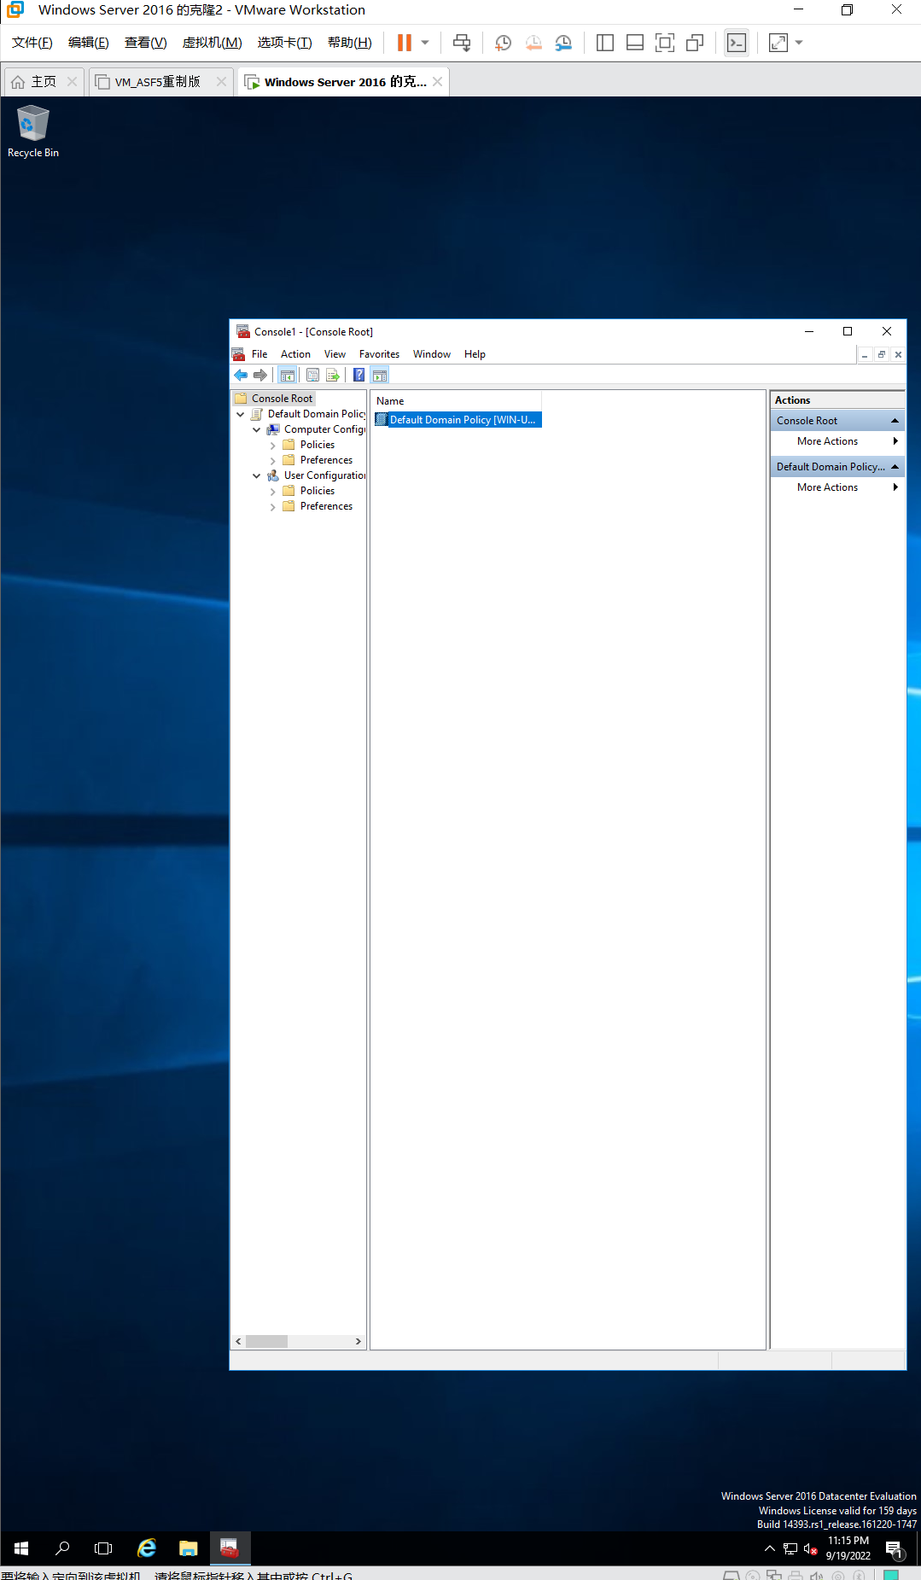

Figure 2.2 The items under Default Domain Policy list

1. In the left pane, click the right pointing arrow in front of Computer Configuration.
2. Double-click the Policies folder in the left pane.
3. Double-click Windows Settings in the left pane.
4. Double-click Security Settings in the left pane.
5. Double-click Local Policies in the left pane.
6. Double-click Audit Policy in the left pane.
7. In the middle pane, notice the audit policies you can enable.

* What would you select to audit logons? What would you select to audit account management activity, such as account creation and changing a password for a user?

Answer:

Audit logon events can audit logons

Audit account management can audit account management activity

1. In the middle pane, double-click Audit directory service access.
2. Click Define these policy settings. Next click Success and click Failure (to audit successful completion of an action and failure of an action). Click OK. Notice the right portion of the middle pane shows you have configured Success, Failure for this option.

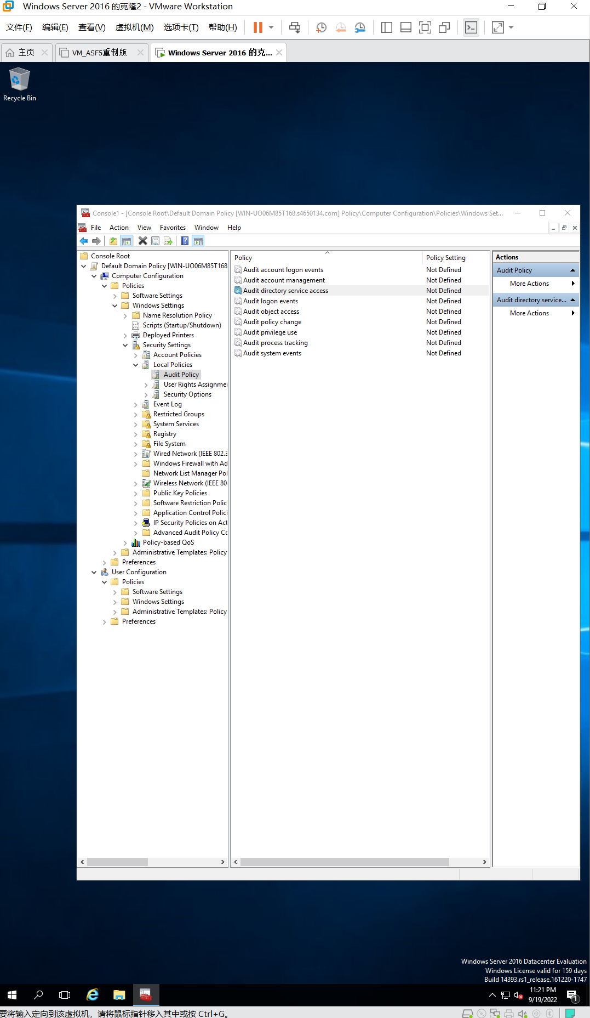

Figure 2.3 Define policy settings

1. In the middle pane, double-click Audit object access.
2. Click Define these policy settings. Next click Success and click Failure. Click OK.
3. Close the Console1 MMC window. Click Yes, provide a name for the console, such as Default Domain Policies, click Desktop to save it on the desktop, and click Save.

# Activity 4-3: Configuring a Shared Folder

**Time Required**: Approximately 20 minutes

**Objective**: Configure a shared folder, share permissions, and offline access.

**Description**: As a server administrator, one of the most important tasks you perform is to enable folder sharing. In this activity, you configure a folder to be shared over the network.

**Requirements**: Take screenshots on Step 5, 8, 23, and 25. Complete Questions on

Step 4, 19, and 22.

1. Access the MMC console window for Active Directory Users and Computers that you have been using, or click it’s icon on the desktop, if you have saved it to the desktop. Alternatively, you can use the Tools menu in Server Manager to open Active Directory Users and Computers.
2. In the tree in the left pane, display the contents under the domain, such as jpcomp.com.
3. Click Users in the tree.
4. Click the Action menu, point to New, and click Group.

* What defaults are already selected in the New Object–Group dialog box?

Answer:

Group scope: Global

Group type: Security

1. In the Group name box, enter DomainMgrs plus your initials, for example, DomainMgrsJP.

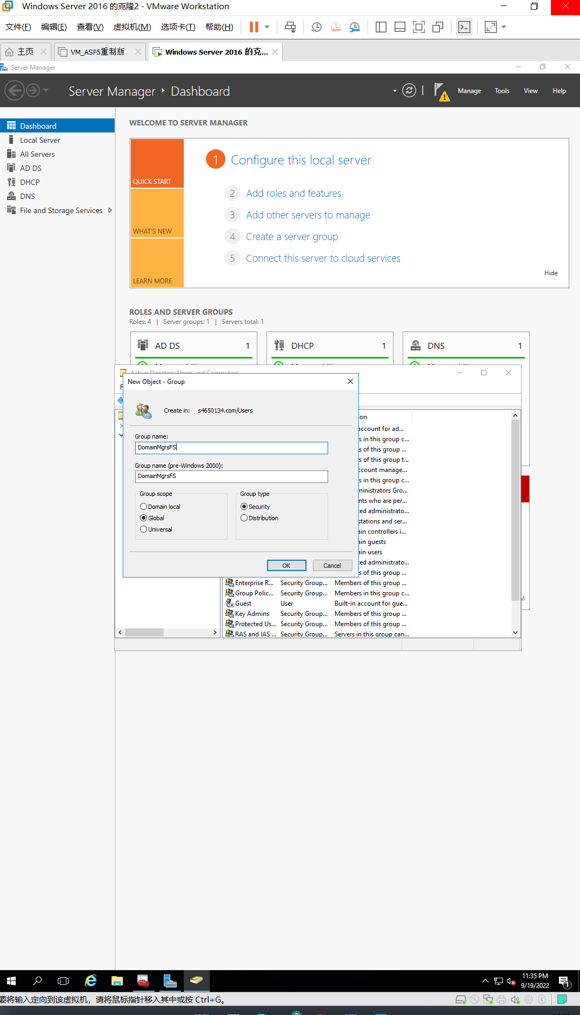

Figure 3.1 Enter group name

1. Click Domain local under Group scope, and click Security (if it is not already selected) under Group type.
2. Click OK and then look for the group you just created in the right pane within the Users folder.
3. Using File Explorer, create a new folder (under the

\Users\Administrator\Documents folder) called Documentation plus your initials, such as DocumentationJR.

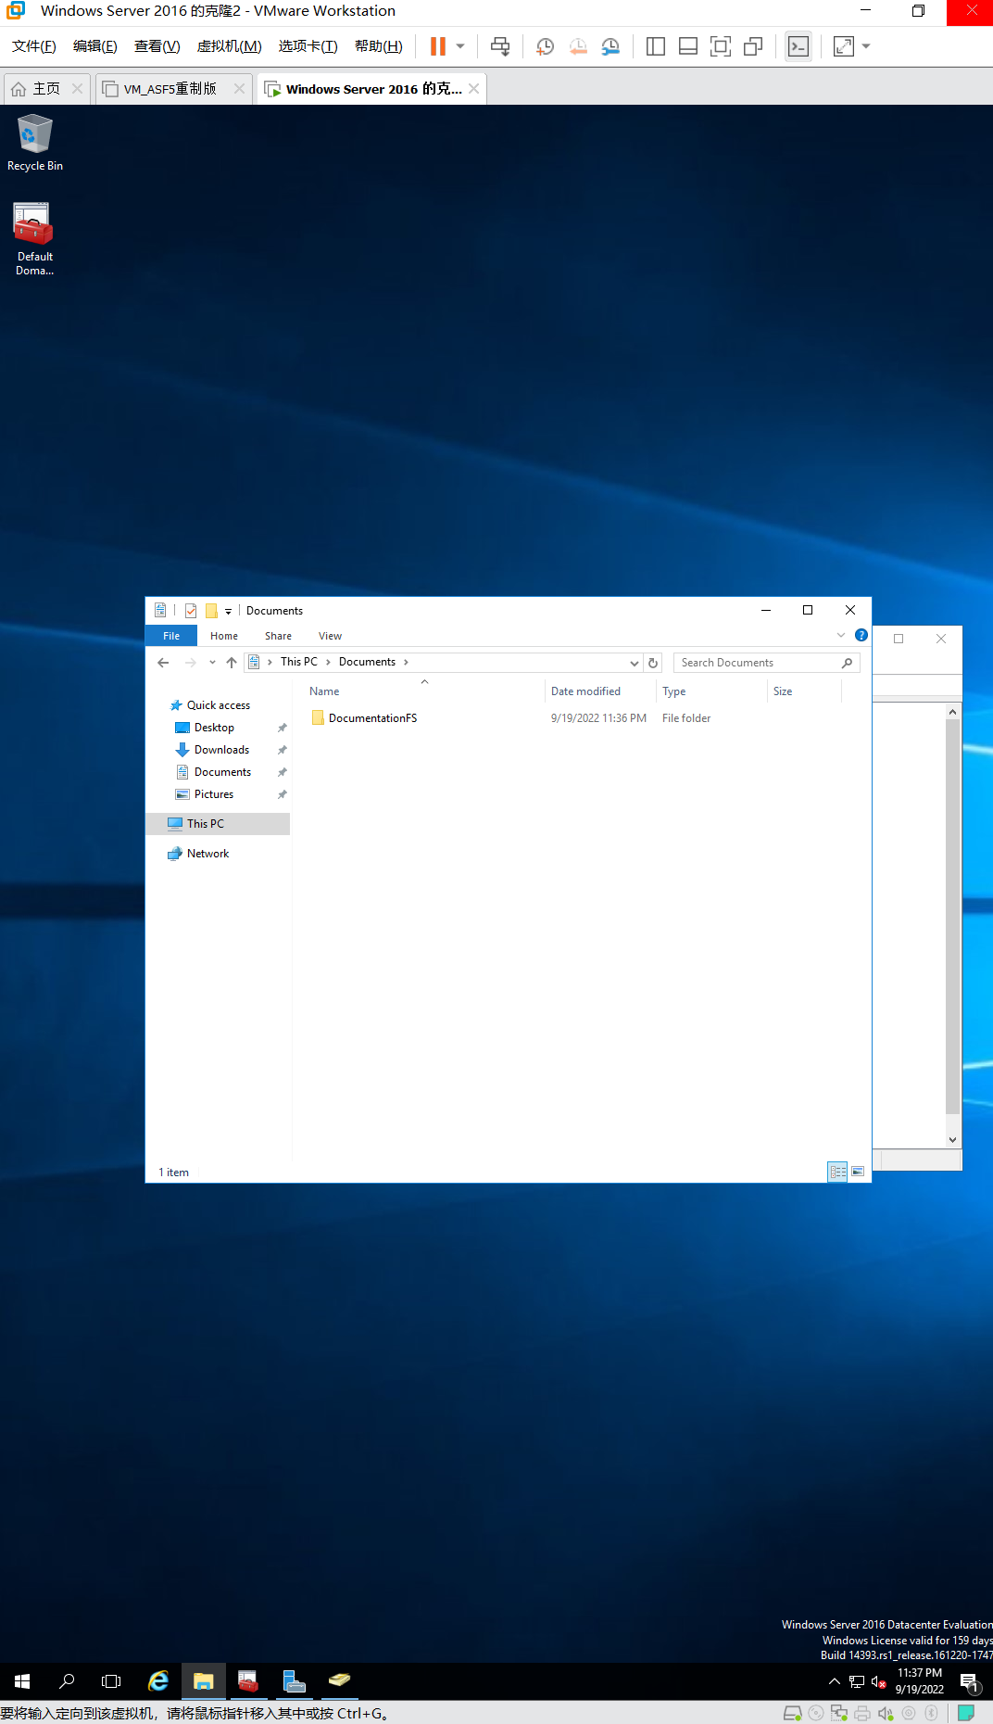

Figure 3.2 New folder creation

1. Right-click the folder, point to Share with, and click Specific people to see the File Sharing window.
2. Click the down arrow next to the Add button and click Find people.
3. Click the Advanced button in the Select Users or Groups dialog box.
4. Click Find Now.
5. Double-click the DomainMgrs group you created in Step 5, such as DomainMgrsJP (DomainMgrs with your initials). Click OK.
6. Click the down arrow for the Permission Level for the DomainMgrs group and click Read/Write.
7. Click the Share button at the bottom of the File Sharing window.
8. The File Sharing window indicates the folder is shared and enables you to email the link for the shared folder or to copy the link into a program. Click Done.
9. In File Explorer, right-click the folder you just shared and click Properties.
10. Click the Sharing tab.
11. Click the Share button.

* What window is now displayed? How would you remove a user or group from those sharing the folder?

Answer:

File Sharing window with administrator and DomainMgrsBHY

Right click the user or group and click the Remove button.

1. Click Cancel.
2. Click the Advanced Sharing button in the Properties dialog box.
3. In the Advanced Sharing dialog box, click the box for Share this folder. Notice that the Share name is the same name as the shared folder.

* How can you change the name of the share? How can you set the limit of users who can access the share at the same time?

Answer:

Change the content in Share name box;

Change the content in “Limit the number of simultaneous users to:” box.

1. Click the Permissions button in the Advanced Sharing dialog box. Notice that the permissions are now displayed as Full control, Change (same as Contribute), and Read. Also, you can select the Allow or Deny boxes for any of the permissions. Further, you can add or remove users and groups. Click Cancel.

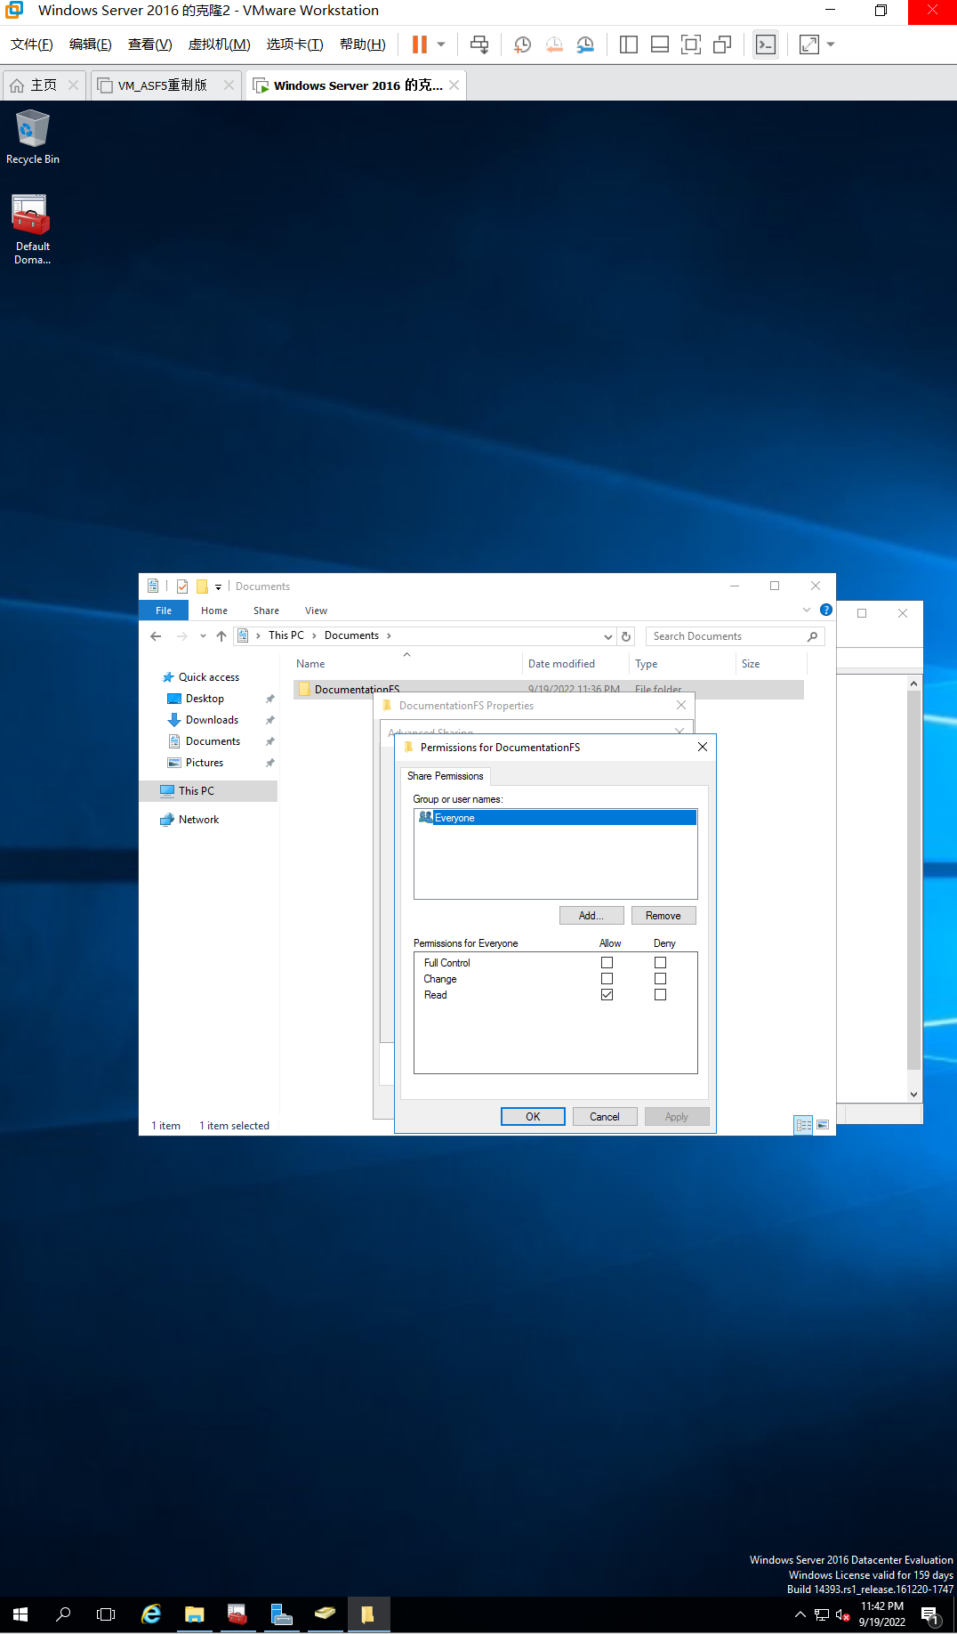

**Figure 3.3 Permissions for the group**

1. In the Advanced Sharing dialog box, click Caching.
2. To configure full offline use, click All files and programs that users open from the shared folder are automatically available offline. Notice that Optimized for performance is enabled by default. Click OK.

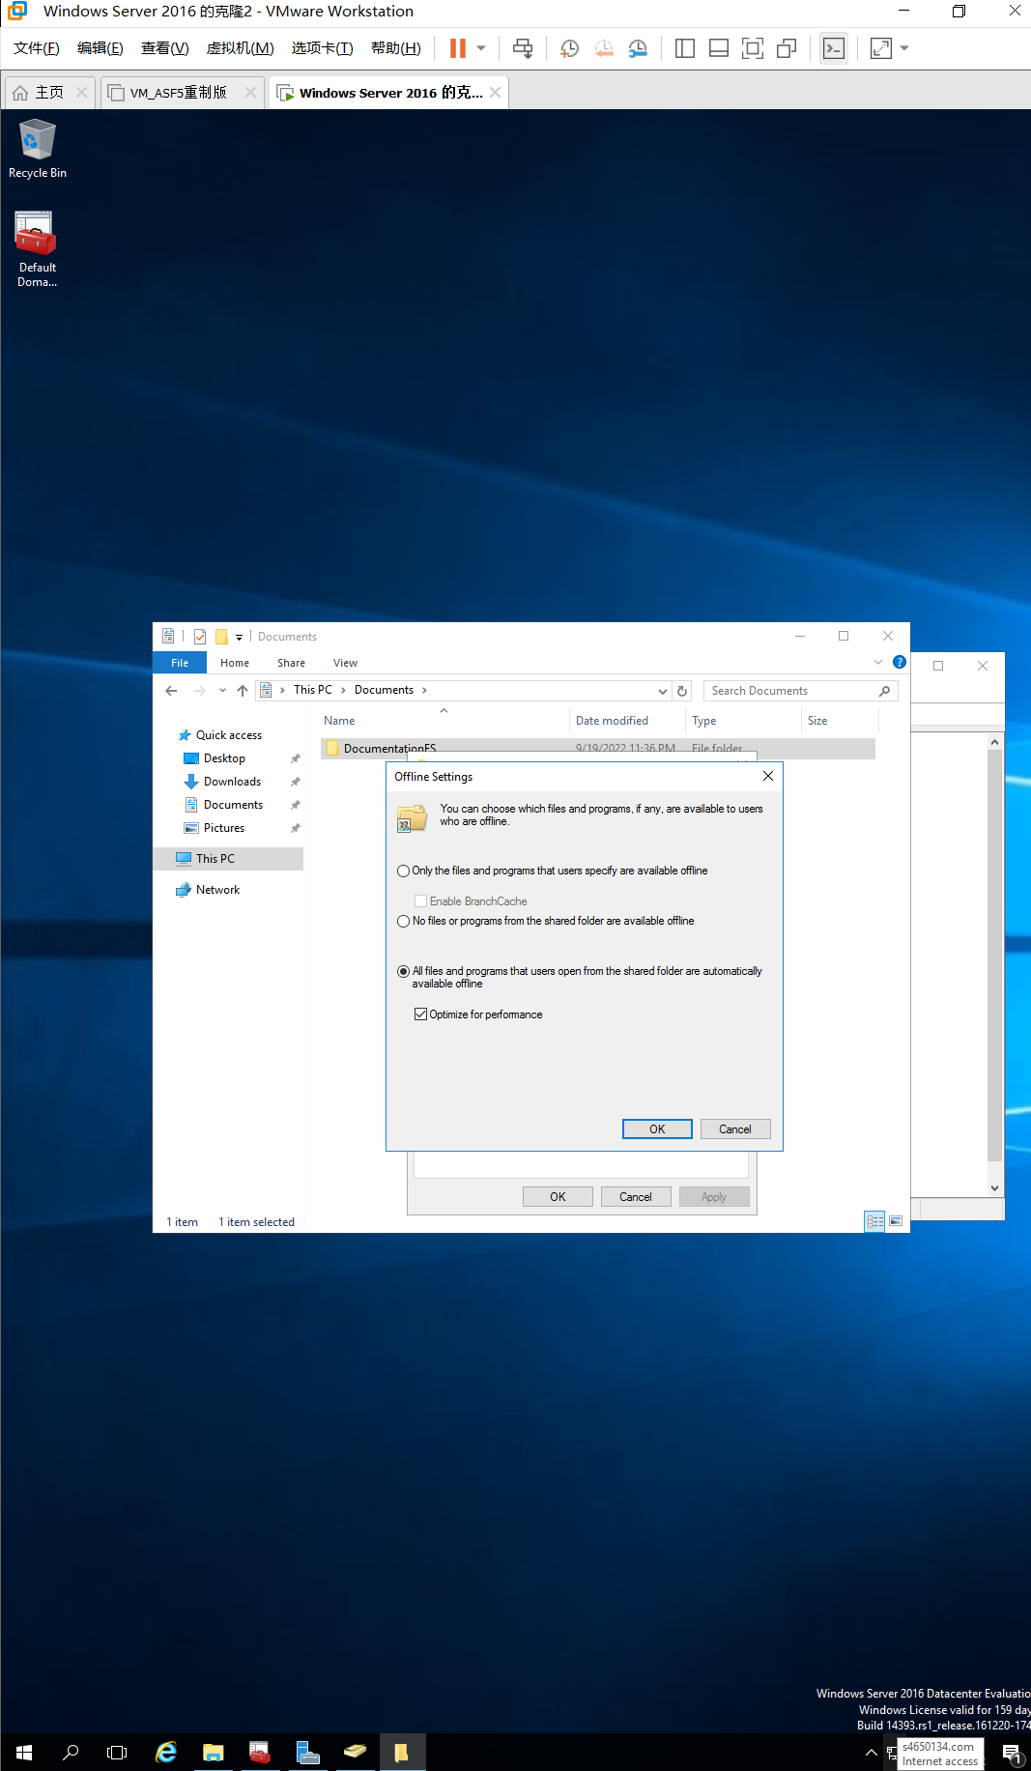

**Figure 3.4 Configure full offline use**

1. Click OK in the Advanced Sharing dialog box.
2. Click Close in the Properties for the folder dialog box. Close File Explorer.

# Activity 4-4: Configuring a Shared Folder Using Server Manager

**Time Require**d: Approximately 20 minutes

**Objective**: Configure a shared folder from Server Manager.

Description: A popular way for a server administrator to configure a shared folder is by using Server Manager. In this activity, you first use Server Manager to install the File Server Resource Manager to enable the use of folder quotas. Next, you use Server Manager to configure a shared folder. The File and Storage Services role should already be installed on the server, which is done by default when you install the operating system.

**Requirements**: Take screenshots on Step 0, 6, 17, 25, 37 and 39, and complete a question on Step 21.

To start this activity, you should create a folder firstly.

1. Open File Explorer (click its icon in the taskbar), if it is not already open. In the Documents folder of your account or of the Administrator account), create a folder called Test plus your initials, such as TestJR. Inside the folder you just created, create a subfolder called Utilities plus your initials, such as UtilitiesJR.

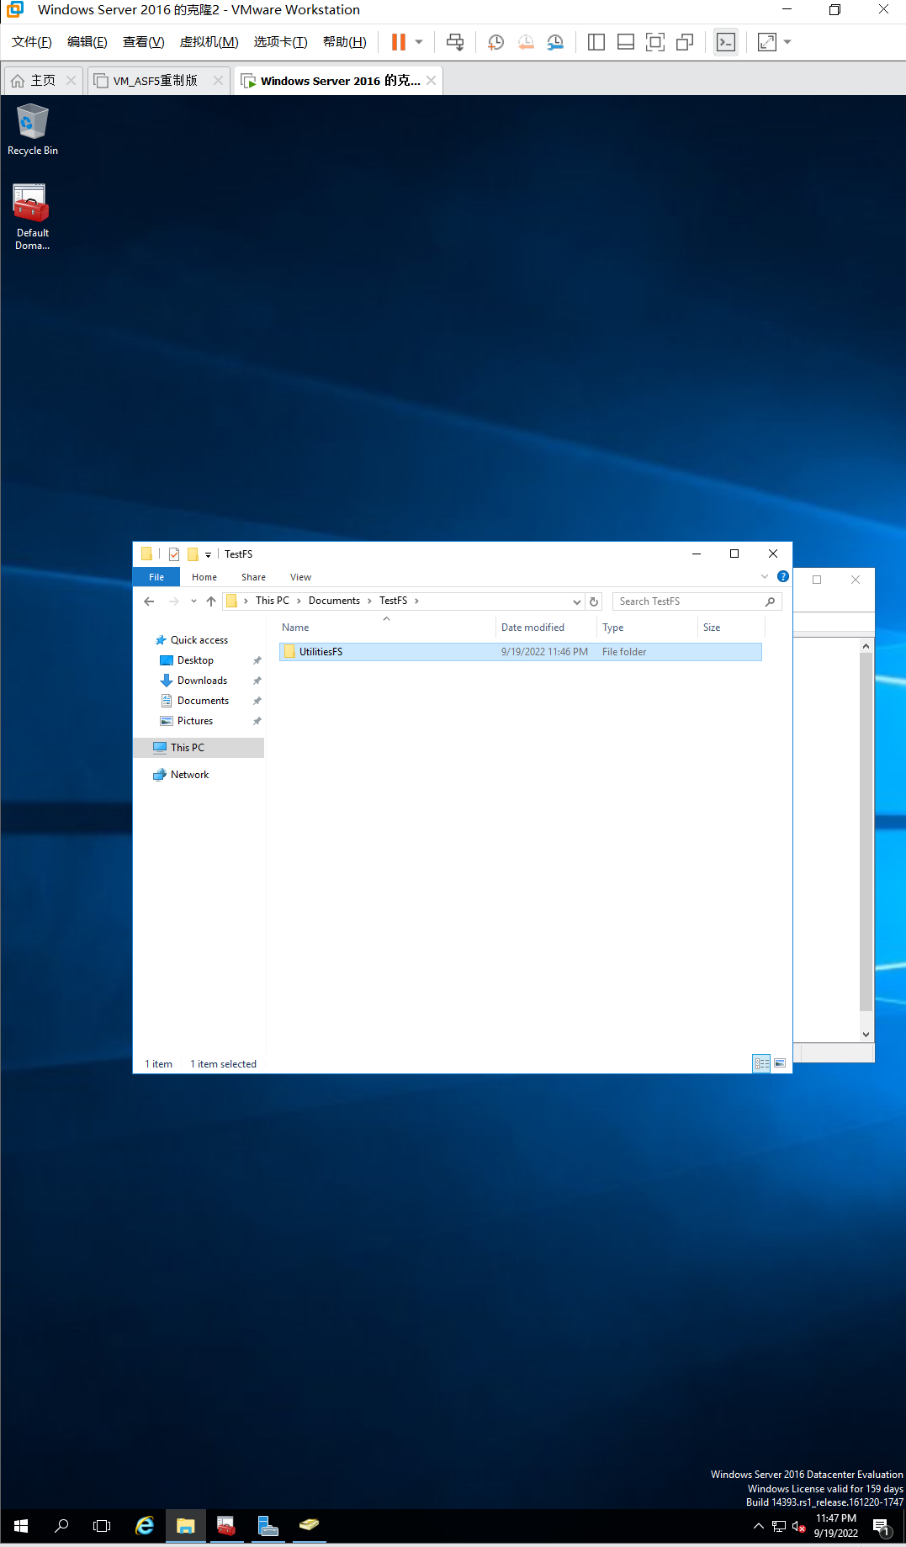

Figure 4.1 Document creation

1. Open Server Manager, if it is not open.
2. Click Manage near the top of the Server Manager window and click Add Roles and Features.
3. Click Next, if you see the Before you begin window.
4. Ensure Role-based or feature-based installation is selected and click Next.
5. In the Select destination server window make sure your server is selected and click Next.
6. Ensure that File and Storage Services is already marked as installed. Click the right-pointing arrow in front of File and Storage Services. Click the right-pointing arrow in front of File and iSCSI Services to view the options under it.

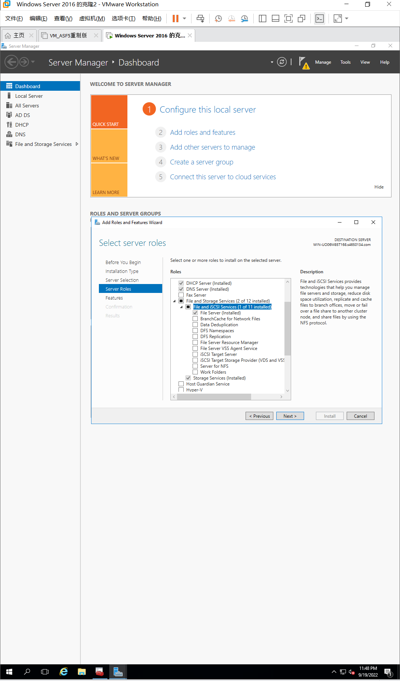

Figure 4.2 Options under File and iSCSI Services

1. Check the box for File Server Resource Manager. (If File Server Resource Manager is already installed, click Cancel and go to Step 13.)
2. If you see the Add Roles and Features Wizard to add additional features, click Add Features.
3. Click Next in the Select server roles window.
4. Click Next in the Select features window.
5. Click Install in the Confirm installation selections window.
6. Make sure the installation was successful and then click Close in the Installation progress window.
7. In the left pane of Server Manager, click File and Storage Services.
8. Click Shares in the left pane.
9. In the middle pane, notice the Documentation folder that you configured in Activity 4-3 is listed under SHARES.
10. In the middle pane, click the down arrow for TASKS. Click New Share.
11. In the Select the profile for this share window, select SMB Share – Advanced. The profiles are methods established for guiding you through creating shares, presenting options for simple to more advanced situations. Notice that the right pane provides a description of this profile. Click Next.

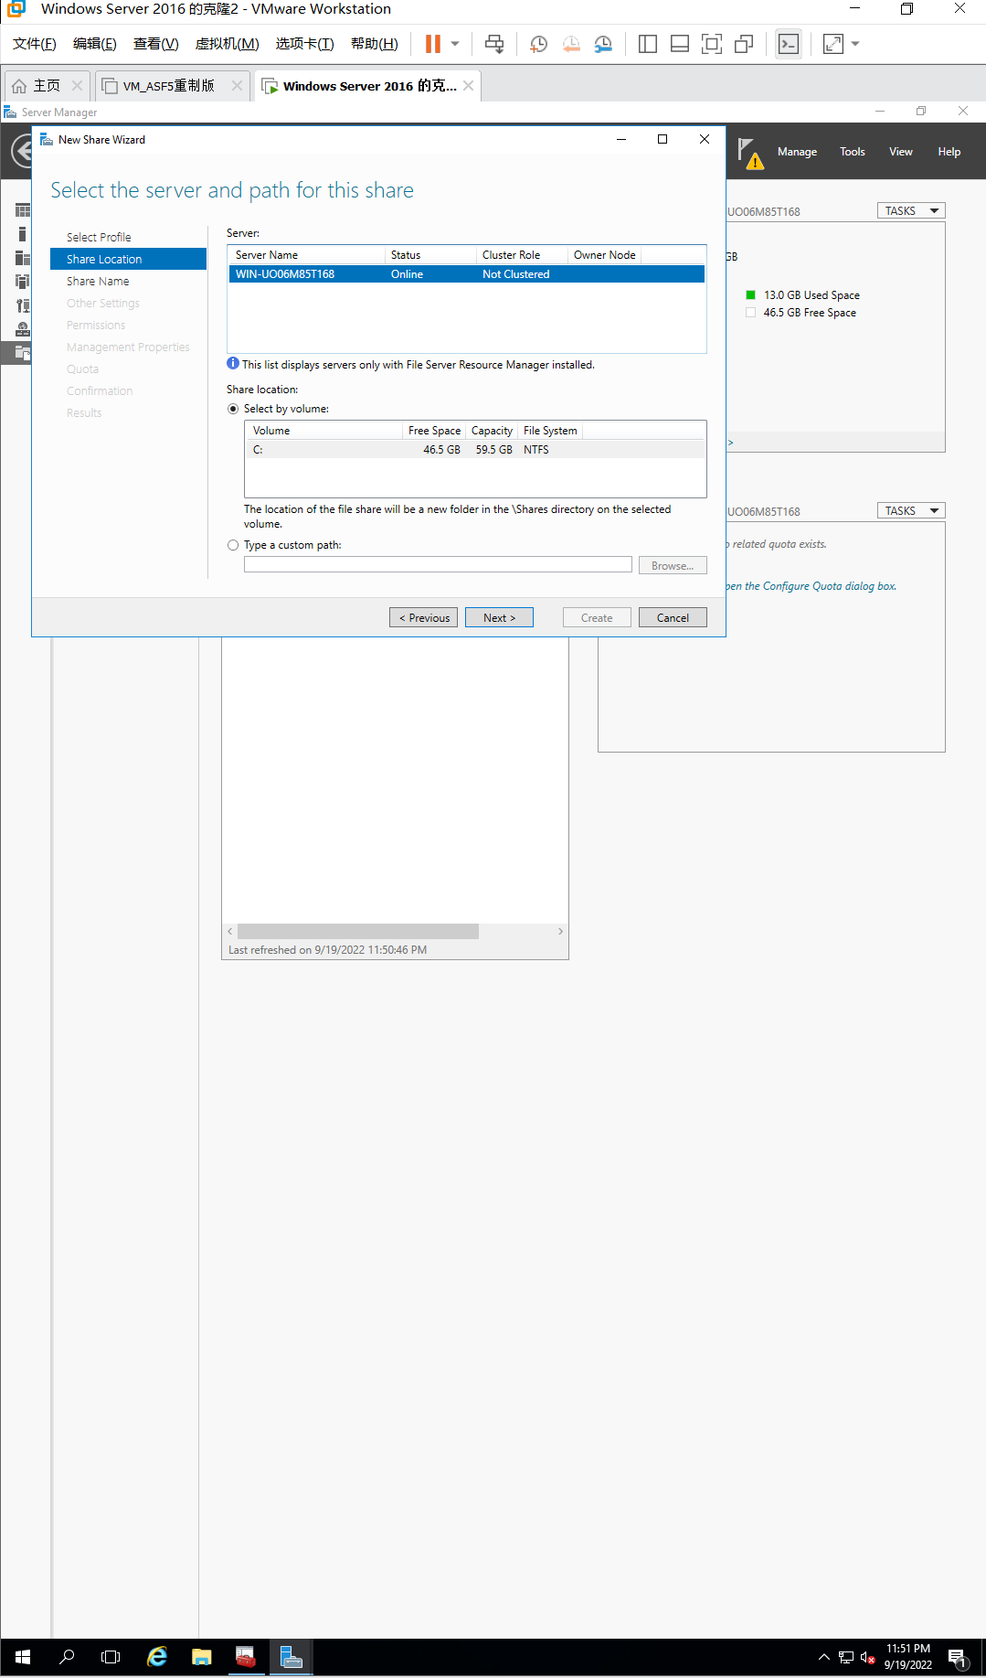

Figure 4.3 Select SMB Share – Advanced

1. In the Select the server and path for this share window, notice that you can select to share an entire drive, if needed. However, for this activity, select Type a custom path. Click the Browse button and browse to the Utilities folder, such as UtilitiesJR that you created in Step 1. For example, browse to users/administrator/documents/TestJR/UtilitiesJR. Click the folder and click Select Folder.
2. Click Next in the Select the server and path for this share window.
3. In the Specify share name window, leave the share name of the folder as the default and click Next.
4. Notice the options available in the Configure share settings window.

* Record the options from which to select. Which option would you use to permit users to view only folders and files for which they have permissions?

Answer:

1. Allow caching to share, enable access-based enumeration, encrypt data access
2. Enable access-based enumeration
3. Ensure that Allow caching of share is selected and click Next.
4. Review the permissions already configured in the Specify permissions to control access window. Click Customize permissions.
5. In the Advanced Security Settings for the folder window, click the Share tab.
6. Click Add.

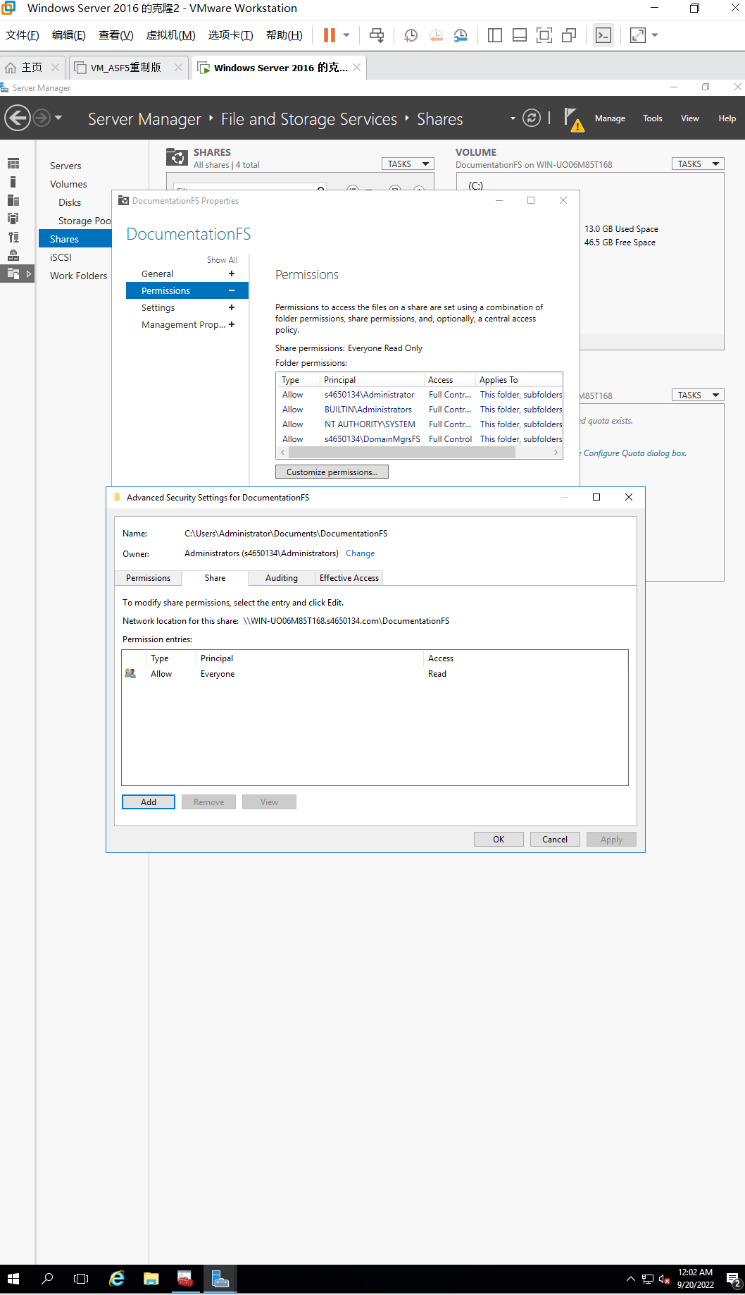

Figure 4.4 Add share permission

1. In the Permissions Entry window for the folder, click Select a principal.
2. Click Advanced.
3. Click Find Now.
4. Double-click the Server Operators group and click OK in the Select User, Computer, Service Account, or Group box.
5. Ensure that Allow is configured for Type and place a check mark in the box for Full Control. Click OK in the Permission Entry for the folder window.
6. In the Advanced Security Settings for the folder window, if the Everyone group is shown, click it and click Remove.
7. Do the same steps on Permission Tab.

*. Click the Permission tab.*

*. Click Add.*

*. In the Permissions Entry window for the folder, click Select a principal.*

*. Click Advanced.*

*. Click Find Now.*

*. Double-click the Server Operators group and click OK in the Select User, Computer, Service Account, or Group box.*

*. Ensure that Allow is configured for Type and place a check mark in the box for Full Control. Click OK in the Permission Entry for the folder window.*

*. In the Advanced Security Settings for the folder window, if the Everyone group is shown, click it and click Remove.*

1. Select Server Operators and click Edit. In the Permission Entry for the folder window, be sure that Full control is selected for the Allow Type. This step ensures that both the folder permissions and the share permissions are the same. Click OK.
2. Click OK in the Advanced Security Settings for the folder window.
3. In the New Share Wizard window, click Next.
4. In the Specify folder management properties window, check the boxes for User Files and Application Files (as you will recall the folder is for server operators to use to run utilities).
5. Click Next.

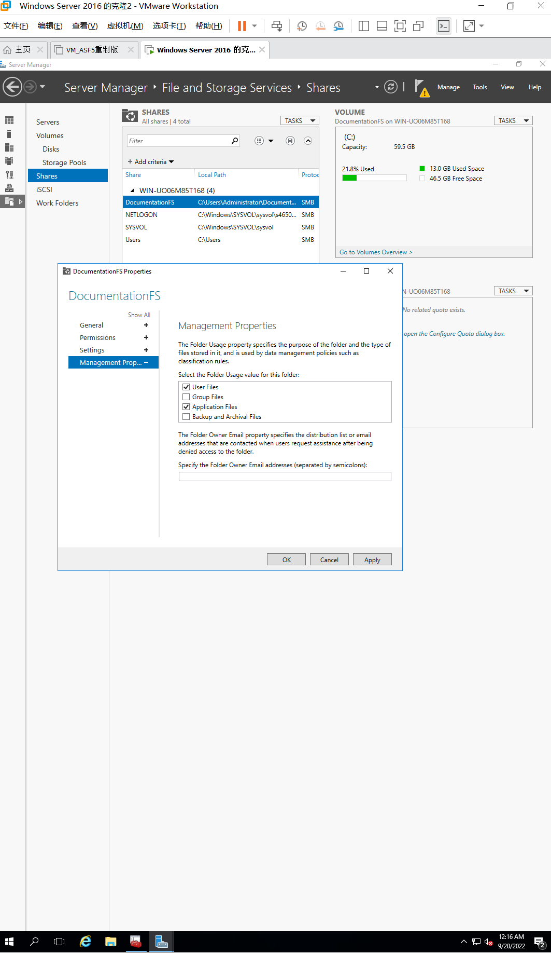

Figure 4.5 Check the boxes for User Files and Application Files

1. In the Apply a quota to a folder or volume window. Click Next.
2. In the Confirm selections window, review your choices and click Create.

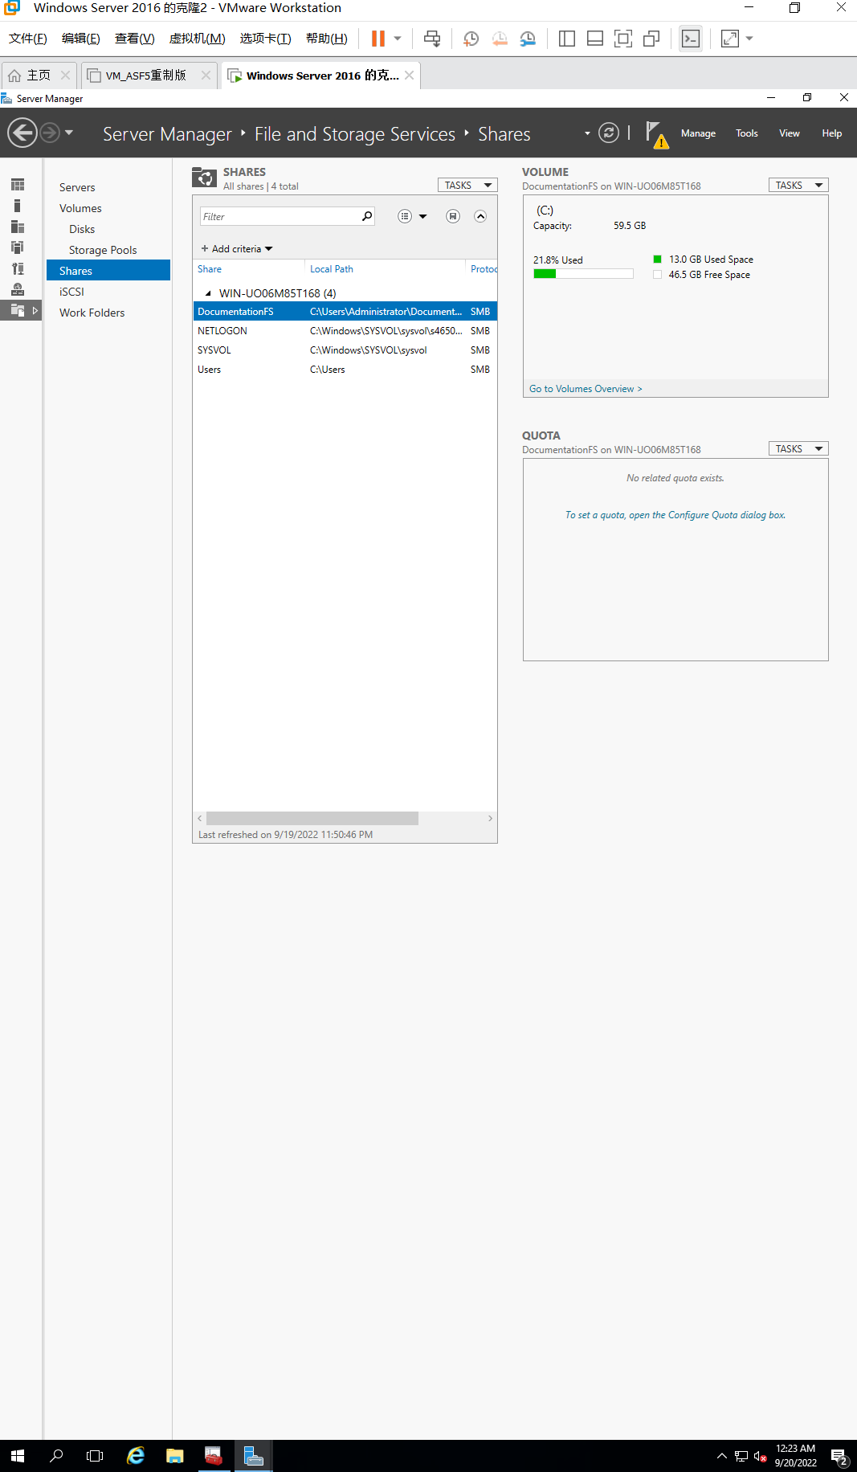

Figure 4.6 Confirmation and Creation

1. Click Close in the View results window.
2. In Server Manager, confirm that your new share is shown under SHARES.